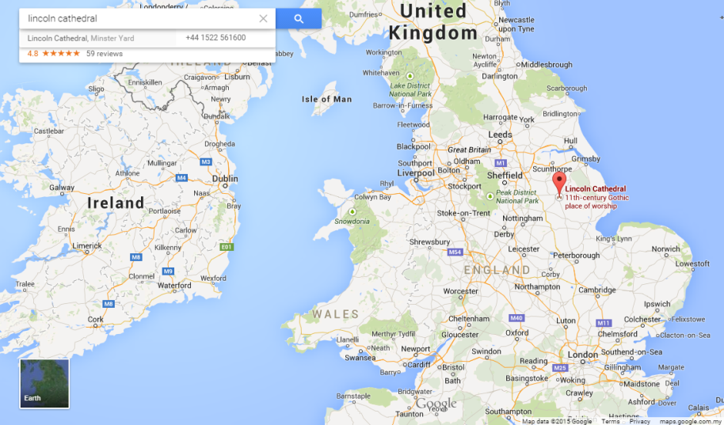
Key Plan
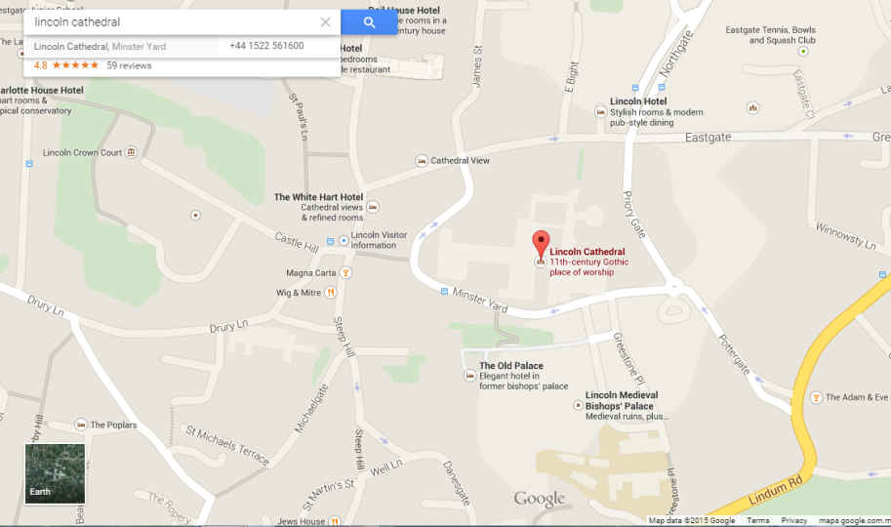
Location Plan
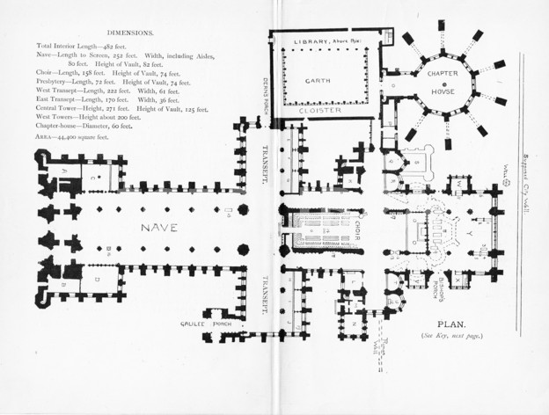
Site Plan

Timeline
1078 - Williams instructed that the Bishopric should be moved to Lincoln
1092 - Lincoln Cathedral (St. Mary Church) was completed within the lifetime of the first bishop, Remigius, who died four days before its consecration.
1141 - Alexander "the Magnificent" (Bishop 1123-48) managed to partially restore the Norman Cathedral after a fire. His contributions include commissioning the famous 12th century Romanesque frieze on the West Front.
1185 - An earthquake (magnitude of over 5) caused structural damage.
1192 - St. Hugh(bishop of Lincoln 1186- 1200) began work on reconstructing the Cathedral. He used the Gothic style, where pointed arches (rather than round ones), ribbed vaults and flying buttresses made it possible to make larger windows (for stained glass) and larger roof spans.
1200 - St. Hugh died before the great Transept and Nave were finished.
1215 - It was another Bishop Hugh who was among those who witnessed King John place his seal on Magna Carta at Runnymeade. The battle of Lincoln Fair took place in the shadow of the cathedral. It is thus fitting that one of the four surviving 1215 copies of Magna Carta belongs to the cathedral and sits with the Charter of the Forest in Lincoln Castle.
1237 - Given the experimental nature of Gothic architecture, mistakes occurred, and the central tower’s collapse
1239 - A major setback.
1255 - A new tower was started immediately. the Dean and Chapter petitioned Henry III to allow them to take down part of the extended town wall to enlarge the Cathedral. They replaced Hugh’s rounded chapels with a larger and loftier square east end to provide more space for the increasing numbers of pilgrims venerating the saint’s shrine.
1280 - This Angel Choir was consecrated.
1307 to 1311 - The central tower was raised to its present height.
1370 to 1400 - The western towers were heightened. All three towers had spires
1549 - The central tower’s spire blew down. It had been the tallest building in the world.
1807 - The similar spires on the west tower was removed.
2006 - The north side of the cathedral has seen the most recent repairs, including the re-building of one of the pinnacles. Work to the North Transept culminated with the restoration of the Dean’s Eye rose window. The Medieval glass was returned to the all new stonework tracery.

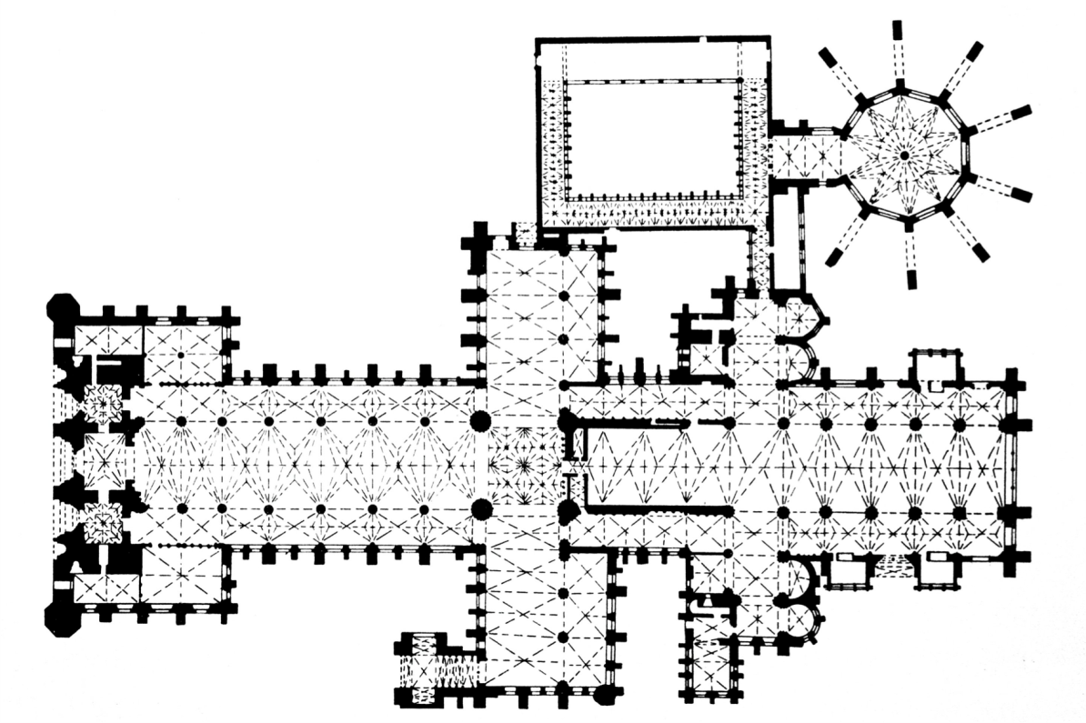
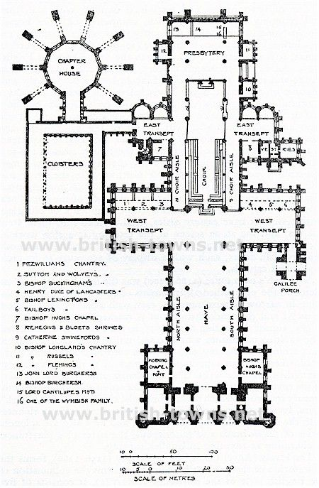 Floor Plan
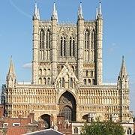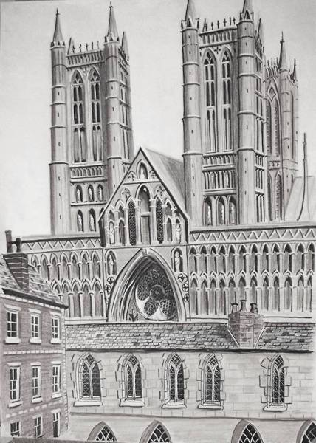
West Front Elevation
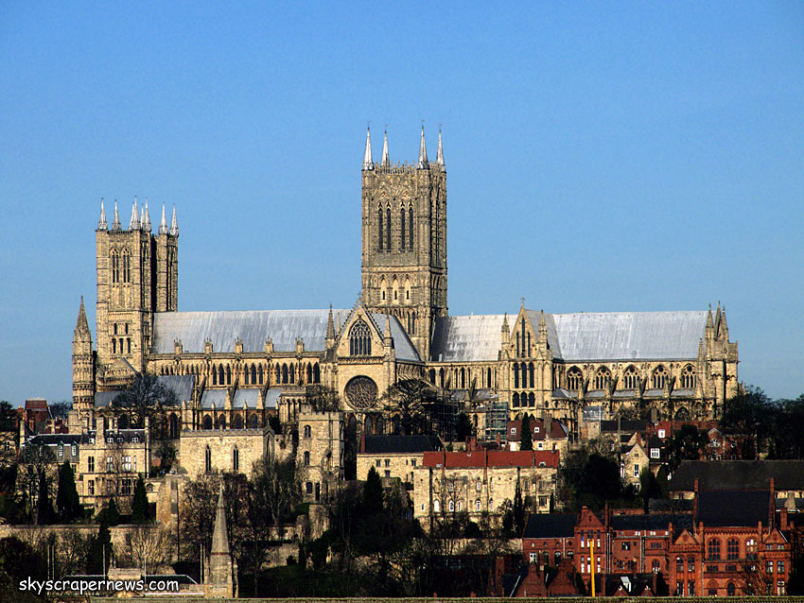
Side Elevation
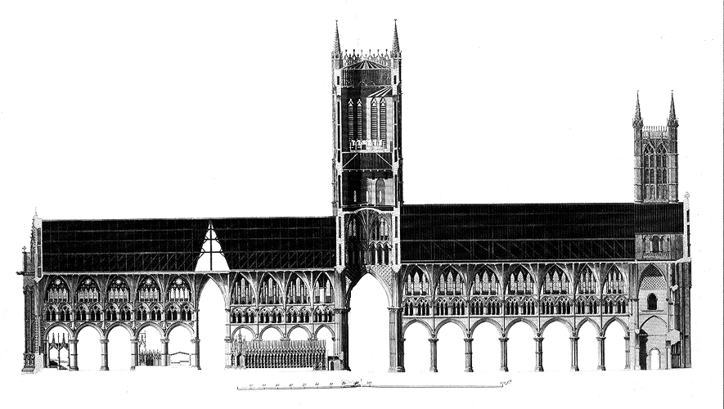

Side Cross Section
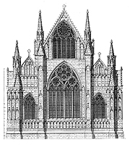
East End Elevation
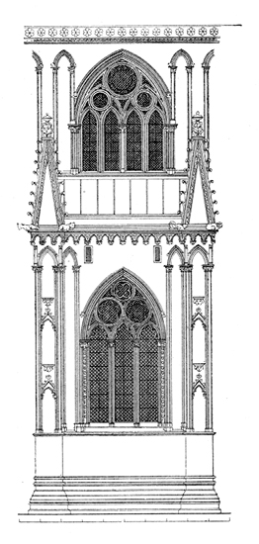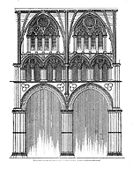
Exterior Elevation Interior Elevation

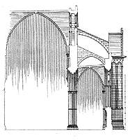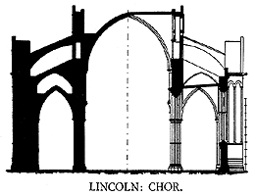
Cross Section of choir Arch Profile of choir
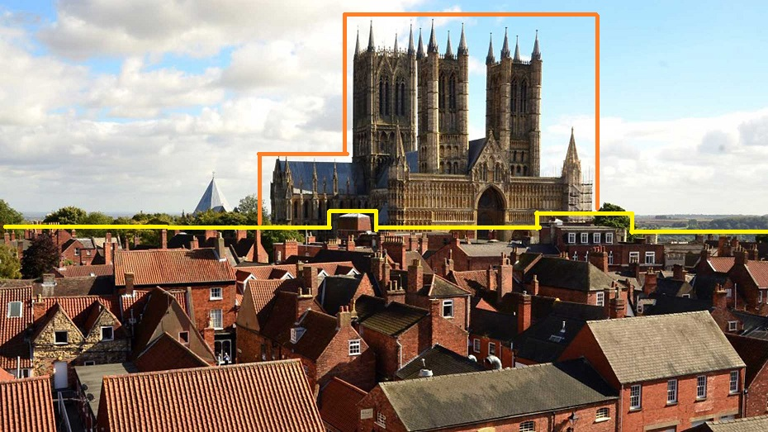
Diagram 1
Diagram 1 shows that the scale of the Lincoln Cathedral is bigger than scale of the buildings around it. Lincoln Cathedral was for almost 300 years the tallest building in the world until the central’s spire blew down in 1549.
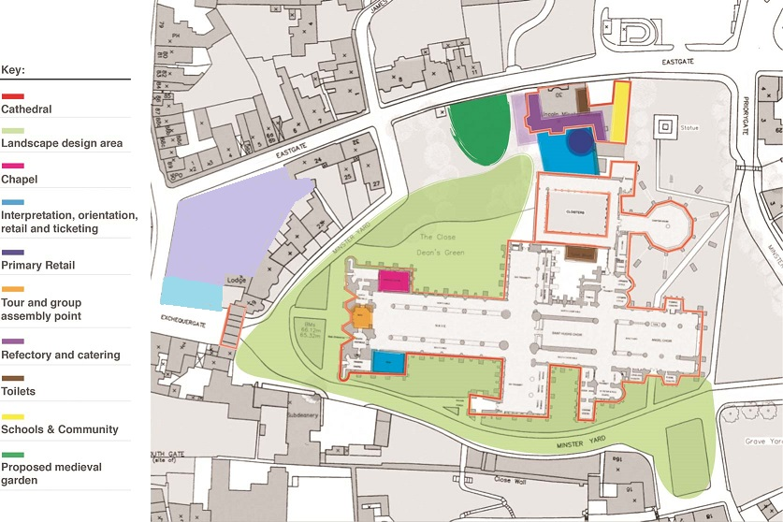
Hotel Church
- Lincoln is the ideal location for gathering, both business and pleasure since 13th century because the nave is a huge public space.
- The library contains an extensive collection of books from the medieval period dating from a copy of the sermons of the Venerable Bede, which was made in the late 10th century, up to date, a span of some 1000 years.
- The Cathedral brings benefit to the shop lots around it as it is a famous attraction in Lincoln.
- Provide education to the community, also giving job opportunities to the community and citizens.

Reference Link
- http://www.medart.pitt.edu/image/England/Lincoln/Cathedral/Mainlincolncathedral.html
- http://easterncathedrals.org.uk/members/lincoln-cathedral.php
- http://penelope.uchicago.edu/Thayer/E/Gazetteer/Places/Europe/Great_Britain/England/_Topics/churches/_Texts/KINCAT*/Lincoln/1.html#zzz
- http://www.britainexpress.com/counties/lincs/churches/Lincoln-Cathedral.htm#heritage
- http://www.british-history.ac.uk/vch/lincs/vol2/pp80-96

